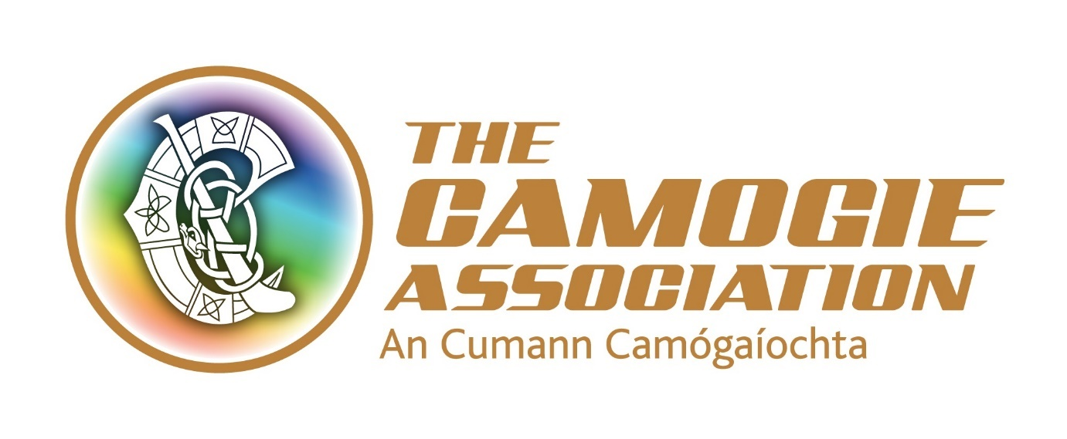
Provincial Participation and Growth Co-ordinator
Munster and Leinster full time roles
Connacht – part time role (3 days equivalent)
The Association is working to a National Development Plan Our Sport Our Future 2016-2019. This post has a key role to achieve the objectives and targets outlined in these.
Under the Plan, the Association is recruiting 3 new posts, Provincial Participation and Growth Co-ordinators who are assigned to work in Munster, Leinster and Connacht.
The key purpose of this role is to develop, manage and support Camogie participation and growth initiatives that support clubs, schools and counties of the Provinces.
The postholder will be an employee of the national Camogie Association.

The post operates in a team environment and the post holder will be expected to work in a collaborative way with staff and volunteer colleagues.

From time to time the post requires working unsocial hours including weekend work and travel.

The office base for the Leinster post is in Leinster GAA Offices, Portlaoise; for Munster it is the Munster GAA Offices, Castletroy, Limerick City and for Connacht it is the Connacht GAA Centre of Excellence, Bekan, Co. Mayo.

The post is offered for a 3 year fixed term contract.

The successful applicant must have a clean driving licence; her/his own transport and will be required to comply with Garda/PSNI vetting clearance in advance of taking up the position.

Salary: The appointment will be attached to a salary scale €31,400- €36,700, commencing in the range €31,400 - €33,000. The salary will be pro-rata for the Connacht post.

Expenses such as travel, overnight accommodation where required and other allowable expenditure will also be paid.

Annual Leave: 23 days’ annual leave. (This will be pro-rata for the Connacht post). In addition, there is additional annual paid leave in the period Christmas Eve/New Year

Other terms and conditions include:
- 7% pension contribution from the Association and subject to employee contribution
- A time in lieu facility (TOIL) for work in excess of weekly contracted hours
- Study leave
- Travel (bike to work scheme/tax saver commuter tickets)

Interviews: Interviews are scheduled for the 28th and 29th March 2017 in Dublin.

Closing date for applications is 5.00 p.m. Friday 10th March 2017.

Please return applications to jobs@camogie.ie or to Recruitment, Camogie Association, Croke Park, Dublin 3

===============================================
JOB DESCRIPTION
Responsibilities of the Provincial Participation and Growth Co-ordinator
- Act as a communication point between national, provincial and county structures by maintaining key communication and relationships on an ongoing basis
- Provide guidance and support to County Boards on day to day governance and administration
- Liaise and collaborate with national programmes and initiatives under the Camogie Association’s National Development Plan, including officer development initiatives for counties and clubs
- Liaise and collaborate with the Provincial Post Primary Council(s) in relation to the Post Primary Fixtures programme on an ongoing basis
- Maintain key lines of communication with clubs and schools to ensure the effective promotion of Camogie through Club School links
- Identify the coach and referee education needs within the Province and support and facilitate delivery of courses and initiatives to meet these needs including those in accordance with the Camogie Association’s National Development Plan
- Monitor and report on active coach data and membership trends across the Province
- Monitor and report on games programmes, within counties and across the Province, that are appropriate to the age and ability of the various playing groups, in accordance with the Camogie Association’s National Development Plan
- Review and administer Provincial development leagues, development competitions and agreed development initiatives
- With the Provincial Council Development Officer, co-convene the Provincial Network of County Development Officers
- Support designated counties in their development work
- Supervise and support interns, work placements and occasional contract work as appropriate
- Maintain key lines of communication with clubs and schools to ensure the effective promotion of Camogie through Club School links
- Undertake any other duties as requested by the Ard Stiúrthóir
A staff member’s job description forms part of her/his contract of employment.
The roles and responsibilities of staff may change subject to the business needs of the Association, in consultation with the staff concerned.

Person Specification
Essential
- A minimum of 2-3 years’ professional experience in a similar role
- The ability to establish strong effective relationships with key stakeholders
- A high level of proven organisational ability
- A proven strategic thinker
- Good administrative and IT skills
- Excellent communication skills – verbal, written and presentational
- Experience of working as a team member
- Be a dynamic self-starter with a proven ability to work independently
- A flexible approach
- Clean full driving licence and own transport

Desirable criteria
- A third level degree in sports, communication, business management or other relevant area
- Experience of working with community and voluntary organisations
- Experience of working in the sports sector, especially Gaelic games
- Knowledge of the Camogie Association and its structures

February 2017

At the time of writing for the Leinster post the designated counties are Kilkenny, Carlow and Wexford; the Munster post is designated Tipperary, Kerry and Clare; the Connacht post is designated Roscommon.

