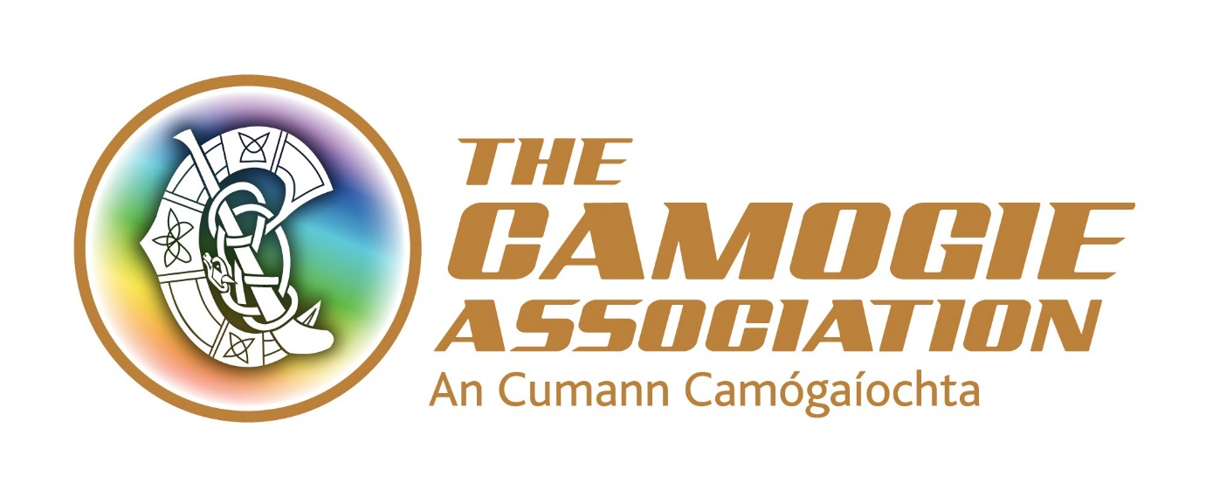
Finance Manager
Job Description and Person Specification
Role and responsibilities
The full-time Finance Manager is part of the Senior Management Team of the Camogie Association and reports to the Ard Stiúrthóir of the Association.
The post holder’s primary responsibilities include management and control of the Association’s financial resources and supporting the Ard Stiúrthóir and the Ard Chomhairle’s Resource Management Committee to carry out their governance and strategic responsibilities, particularly as they relate to financial accountability and decision-making.
The post holder will contribute to the overall vision for the Association and will lead the strategic management and development of its Finance function.
The post holder will be required to have access to transport/a clean full driving licence and the appointment will be subject to Garda vetting clearance.
This is a permanent post with a 9-month probationary period.
Key responsibilities include:
Management and control of financial resources
- Lead the development of the Association’s finance function; including managing and interpreting financial reporting to advise and support the development of Camogie
- Ensure the provision of a robust and effective financial infrastructure for the Camogie Association that is compliant with legal, statutory and regulatory requirements and best practice standards
- Provide support and guidance to, and oversight of units affiliated to the Camogie Association to comply with relevant financial procedures and best practice standards
- Manage, develop and review financial control policies and procedures for the national Association, and its affiliated units, as appropriate
Budget and risk management
- Prepare financial forecasts, budgets and management accounts for management and Ard Chomhairle and in preparation for annual audit
- Develop and manage value for money analysis of major initiatives, as appropriate, to support the Association’s decision-making processes
- Oversee financial risk management at all levels of the Association including liaison with relevant parties re appropriate insurance
Organisational management and administration
- Manage all payroll functions for the Association
- Manage Finance staff and mentor and support national Association staff to work in compliance with the national Association’s financial procedures and best practice standards
- Oversee and support the administration of the online membership registration system, including reconciliation of payments received
- With the Ard Stiúrthóir and relevant staff, negotiate with and manage financial relations, procurement and contracting with third parties including suppliers and service providers
- Engage and contribute to the delivery of organisational development and change management, strategic planning and annual business planning
- Support and attend the Association’s Resource Management and Risk Management Committees
- Undertake any other duties as directed by the Ard Stiúrthóir

Person Specification

Essential criteria
- Professional accounting qualification (ACA, ACCA, CIMA) with a minimum of 3 years post qualification experience or a minimum of five years’ experience running management accounts and producing financial statements within a small/medium size company.
- Experience in all aspects of running an effective financial infrastructure including budgets, management accounts, and managing, developing and reviewing financial control policies and procedures.
- Excellent IT skills with a comprehensive knowledge of accounting and payroll packages.
- Excellent interpersonal and communication skills with the ability to build effective relationships internally and externally with a wide range of stakeholders.
- Strong planning and organisational skills.
- A highly motivated and positive approach.
- Ability to work on own initiative.
- Experience of managing staff.
All candidates must meet the essential criteria to be eligible for entry in the recruitment competition.

Desirable criteria
- Experience of working with community and voluntary organisations, especially in the sports sector is an advantage
- Knowledge and experience of procurement processes.
- Experience of managing a year-end audit.
- Knowledge and experience of relevant legal, statutory and other regulatory requirements.

Terms and conditions
- The post is based in the Camogie Association’s offices in Dublin.

- The appointment will be attached to a salary scale ranging from €45,500-€51,500.

- Expenses such as travel, overnight accommodation where required and other allowable expenditure will also be paid.
- A pension contribution from the Association, subject to employee contribution. The contribution is either 3% or 7% by agreement.
- The post holder will be required to have access to transport/a clean full driving licence and the appointment will be subject to Garda/PSNI vetting clearance.
- The Finance Manger will be required to work occasional unsocial hours including weekends. From time to time travel will also be required.
- Annual leave entitlement of 25 days per annum. In addition, there is additional annual paid leave in the period Christmas Eve/New Year
- The Association also provides study leave and facilitates a bike to work scheme/tax saver commuter ticket.
Application process and closing date
CVs must be submitted to jobs@camogie.ie by 5.30 p.m. 7th May 2018.
Postal applications can be submitted to Personnel, Camogie Association, Croke Park, Dublin 3 and mark your application confidential.
Late applications will not be accepted.

