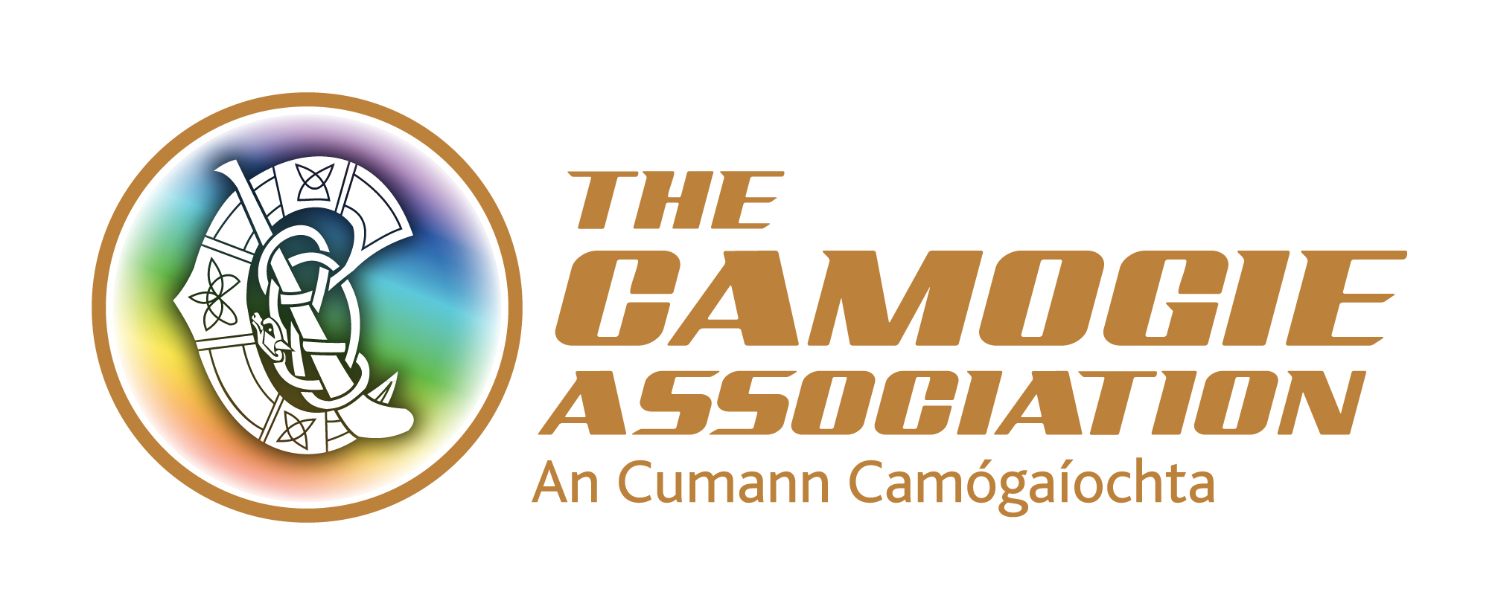
FORMS MUST BE SENT TO info@camogie.ie FROM THE CLUB SECRETARY’S GAA EMAIL ADDRESS (secretary.clubname.county@gaa.ie) before Wednesday September 10th. STRICTLY LIMITED TO 1 APPLICATION PER CLUB. MINIMUM 15, MAXIMUM 35.

2014 ADULT CLUB PASS APPLICATION FORM

FIXTURE:
Camogie Association Final

14-09-2014
Date of Fixture:
Croke Park

Venue:

Club:

Club Secretary’s Name:

club address:

Club Secretary’s

Phone No:

No. of tickets required:

Price – 15 tickets for €200, additional tickets €15 each.

Camogie Reserves Right to Seat Groups in Any Section.
Application form to be emailed to info@camogie.ie on by the deadline above. On receipt of your application a representative of the Camogie Office will be in contact with your Club to arrange payment and delivery. payment in advance is required.

