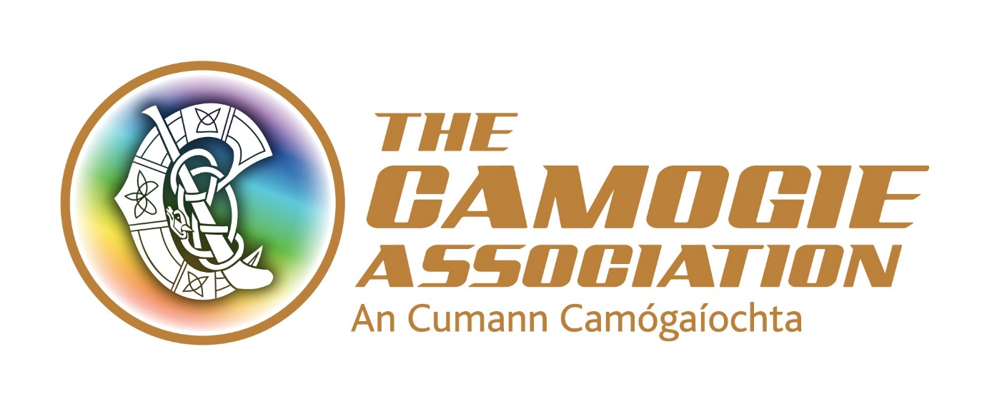Coach Education and Development Coordinator

Job Description

The key purpose of this role is to develop, co-ordinate and support initiatives to support best practice in the recruitment, training and education of coaches and coach tutors within the Camogie Association.
The Association has just finalised a new National Development Plan Our Sport Our Future 2016-2019 and a Player Pathway. This post has a key role to achieve the objectives and targets outlined in these.
The post holder will be required to have access to transport/a clean full driving licence and the appointment will be subject to Garda/PSNI vetting clearance.
Key responsibilities include:
- Plan and oversee the implementation and facilitation of a coordinated programme of activities and events, budget spending, materials production and distribution, and other resources to support the implementation of the Player Pathway and to achieve national objectives on coaching standards and on the education, training and recruitment of coaches and coach tutors
- Ensure that these programmes and initiatives keep pace with changing standards and best practice in coach education
- Ensure that coaches, clubs, county and Provincial Executives are aware of and supported to comply with legal requirements relevant to coaching
- Support Units and county and Provincial Executives to develop and implement effective recruitment and training of coaches and coach tutors with specific attention to increasing the number of active female coaches
- Promote awareness of coach development throughout the Association
- Keep informed of new methodologies, technologies and supports relevant to coach recruitment, education and training, with a particular focus on relevance to female athletes
- Work with the LGFA/GAA to maximise opportunities for integrated and aligned coaching development
- Act as the Association liaison with Coaching Ireland
- Roll out national programmes and initiatives under the Camogie Association’s National Development Plan
- Liaise with relevant Ard Chomhairle committees and Units as appropriate
- Supervise and support interns, work placements and occasional contract work
- Represent the Association
- Support designated counties
- Undertake any other duties as requested by the Ard Stiúrthóir

A staff member’s job description forms part of her/his contract of employment. The roles and responsibilities of staff may change subject to the business needs of the Association, in consultation with the staff concerned.

Person Specification
Essential Criteria
- A third level degree in sports science, education or other relevant area
- A minimum of 2-3 years’ experience in a similar role
- Knowledge and experience of sports coaching and/or tutor education
- Knowledge and experience of adult learning methodologies
- Knowledge and experience of designing and/or developing course syllabus and course learning materials in sports coaching or related field
- Exceptional interpersonal skills, proven ability to work and develop relationships to achieve targets
- A high level of proven organisational and administrative ability including competency in Microsoft Office
- Excellent communication/presentation skills (verbal and written)
- Access to transport and/or a clean full driving licence

Desirable criteria
- Knowledge of coach education structures in Gaelic Games, particularly Camogie
- Camogie or GAA Coaching Accreditation
- Ability to update content on web and social media
- Budget management

Terms and conditions
The post will be designated to one of the Camogie Association’s office - head office in Dublin or regional offices in Armagh, Ballyhaunis, Athlone or Limerick.

The post is a permanent positon with a 9-month probationary period.

The Coach Education and Development Co-ordinator will be required to work unsocial hours including weekends. From time to time travel will also be required.

The successful applicant must have a clean driving licence; her/his own transport and will be required to comply with Garda/PSNI vetting clearance in advance of taking up the position.

The appointment will be attached to a salary scale ranging from €31,400- €36,700.

Expenses such as travel, overnight accommodation where required and other allowable expenditure will also be paid.

Other terms and conditions include:
7% pension contribution from the Association and subject to employee contribution
Annual leave entitlement of 23 days per annum. In addition, there is additional annual paid leave in the period Christmas Eve/New Year
A time in lieu facility (TOIL) for work more than weekly contracted hours
Study leave
Travel (bike to work scheme/tax saver commuter tickets)

County(ies) to be determined

